WonBin Seo
Dr. Shannon Nicley,
ECE 813 Advanced VLSI Design
16 April 2025
Exam3
Problem 1 – 1-bit SRAM Schematic
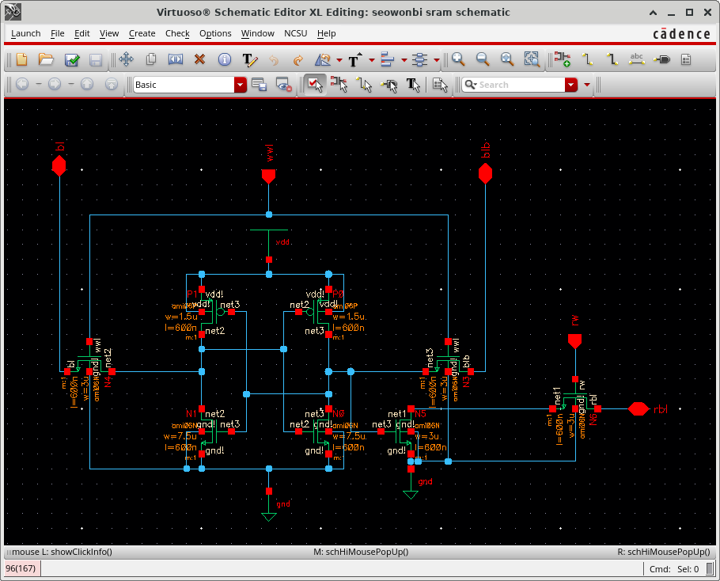

Problem 1 – 1-bit SRAM Symbol
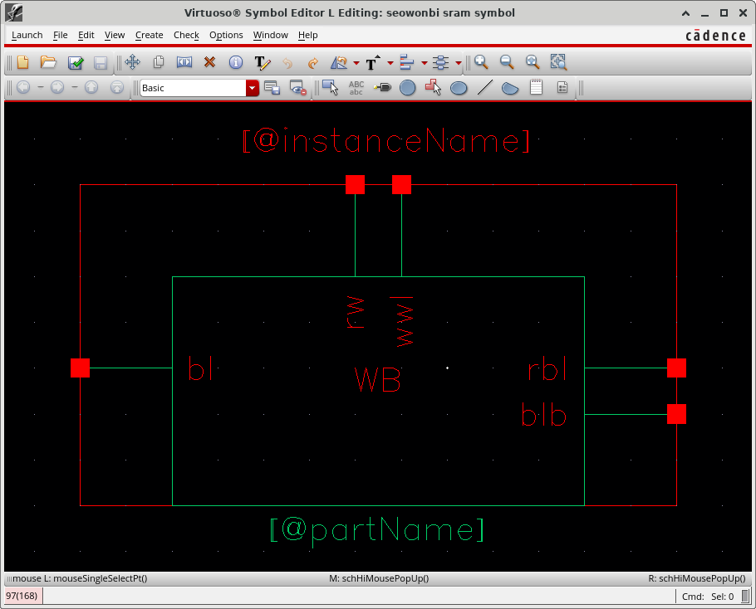

Problem 1 – 1-bit SRAM Layout
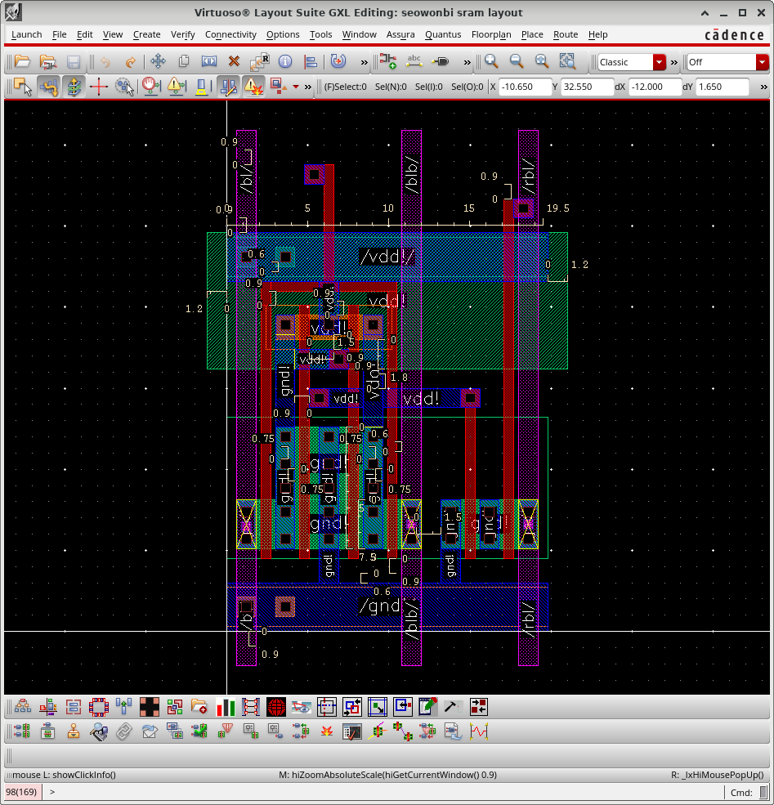

Problem 2 – Bitline Conditioning Schematic
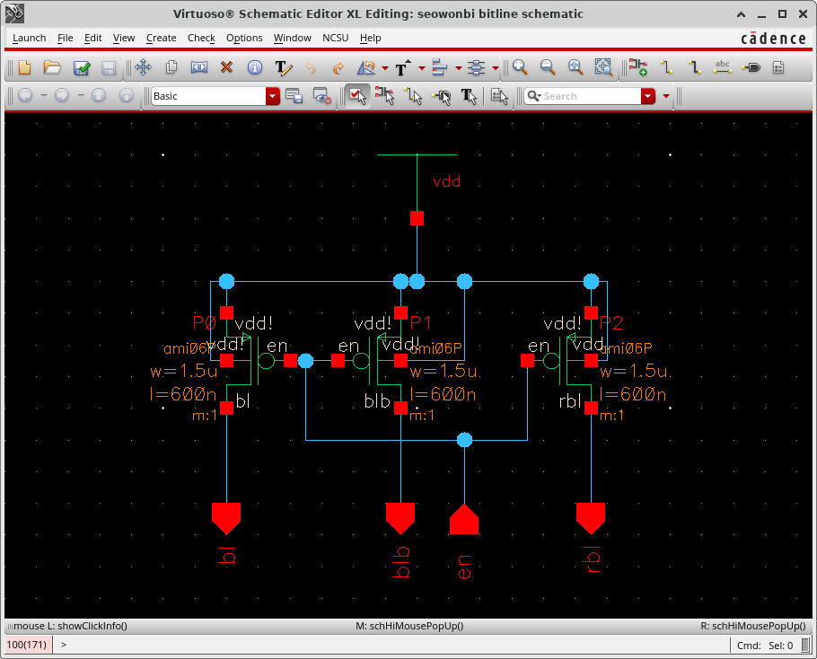

Problem 2 – Bitline Conditioning Symbol
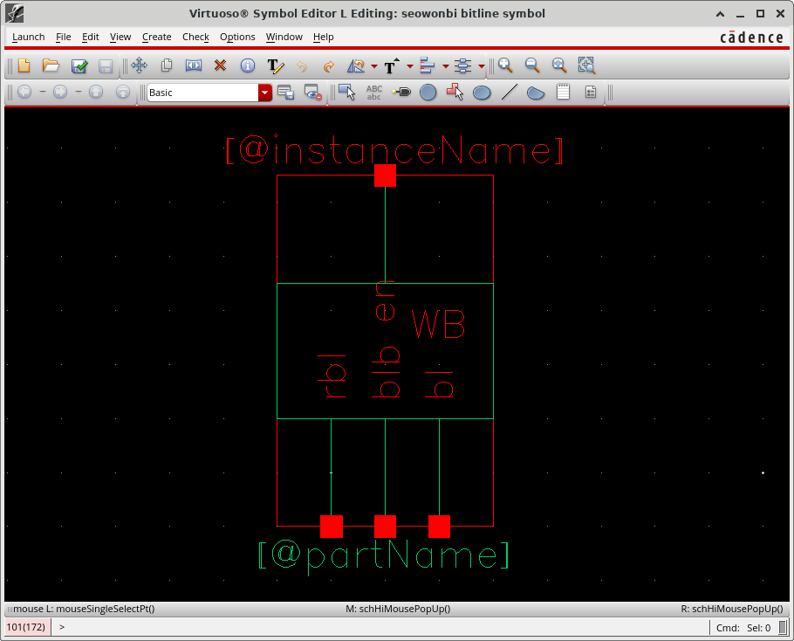

Problem 2 – Bitline Conditioning Layout
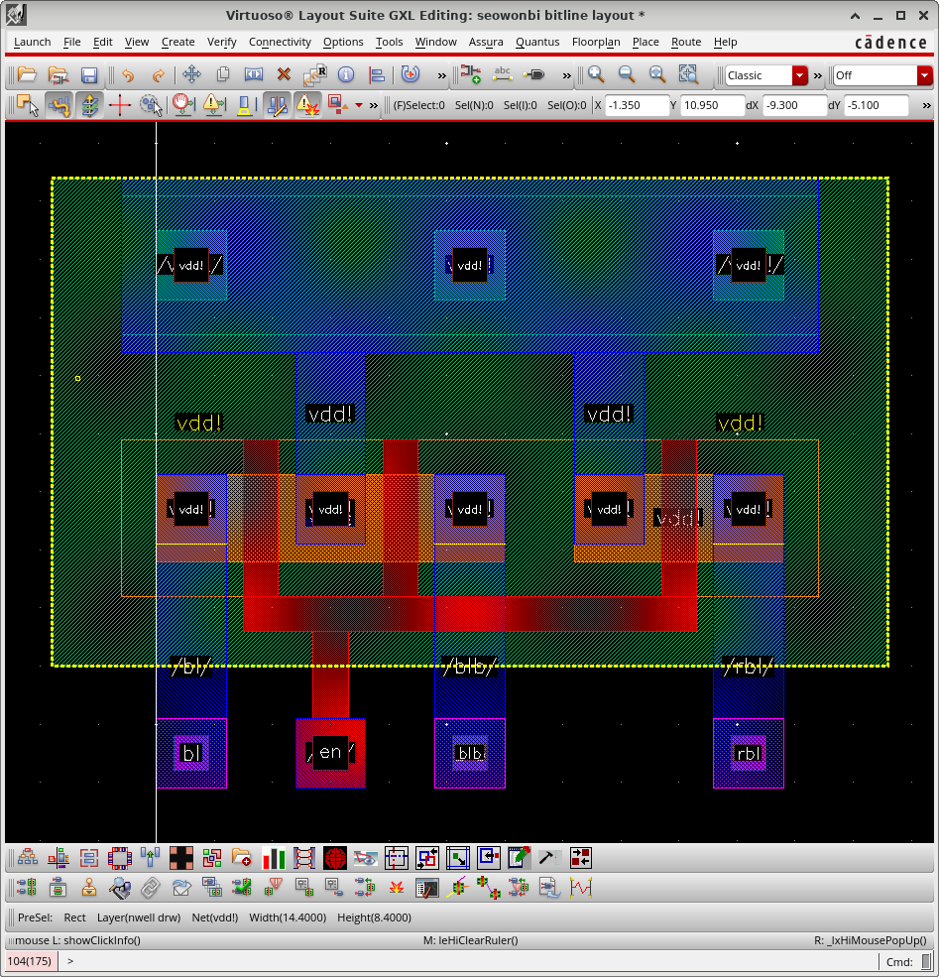

Column Circuitry Schematic
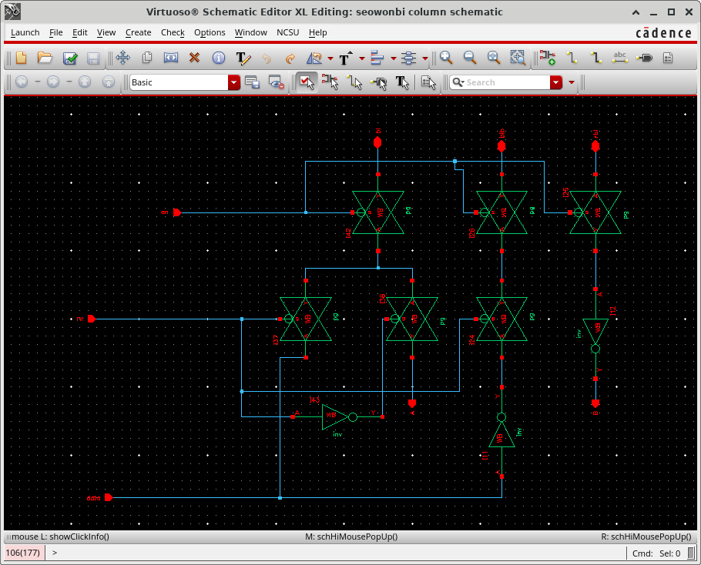

Problem 3 – Column Circuitry Symbol
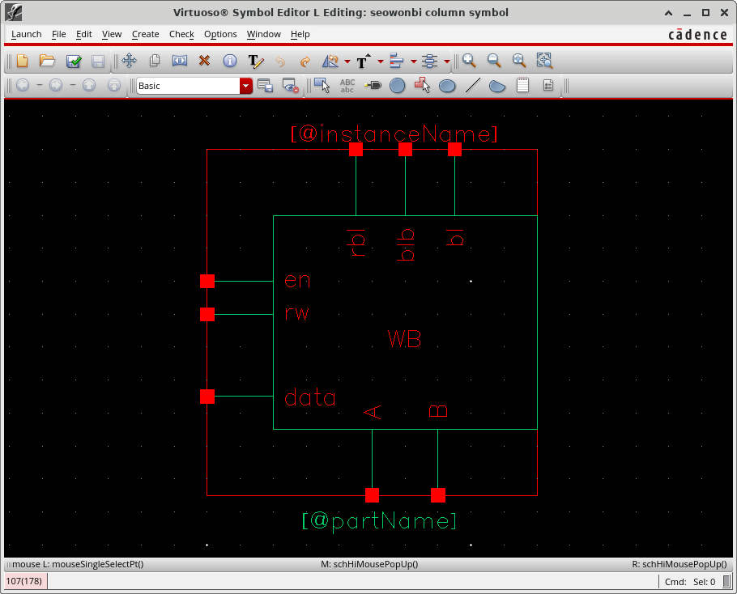

Problem 3 – Column Circuitry Layout
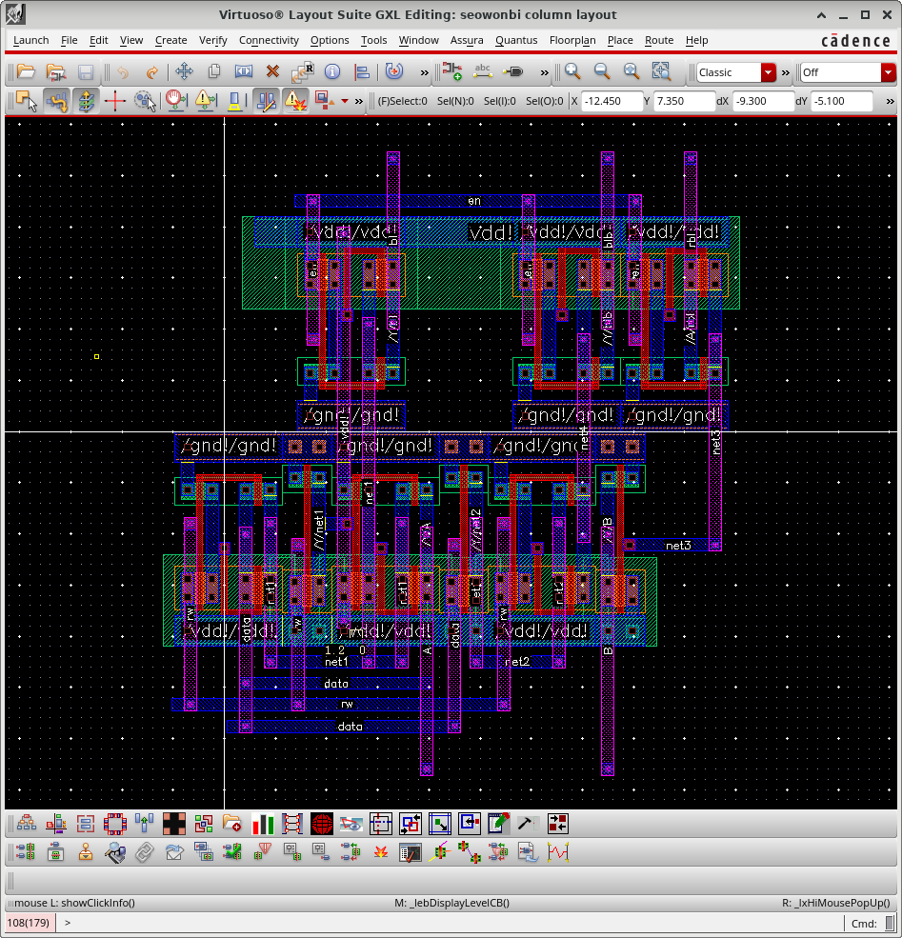

Problem 4 – 8-bit SRAM Column Schematic
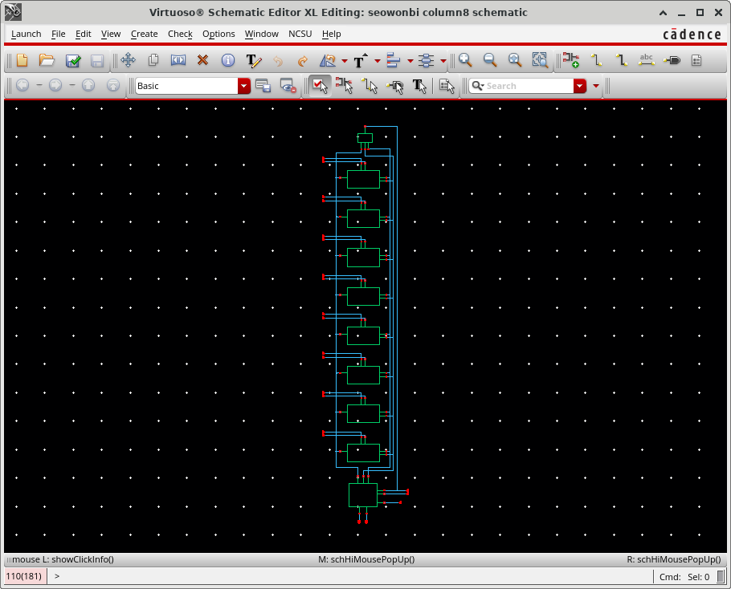

Problem 4 – 8-bit SRAM Column Symbol
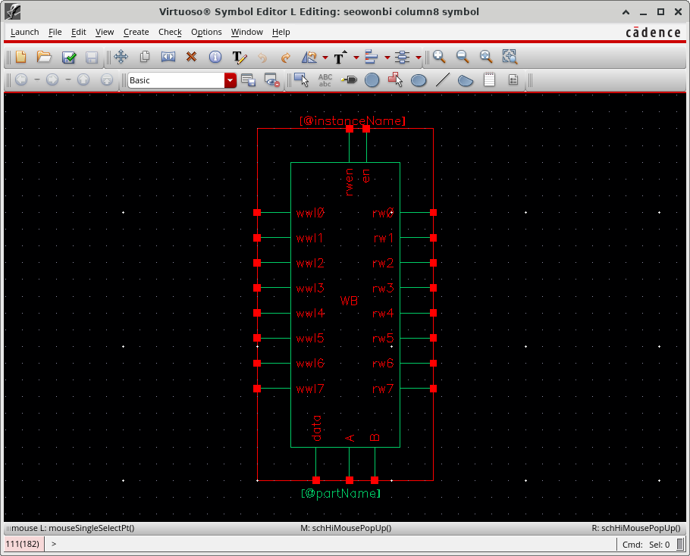

Problem 4 – 8-bit SRAM Column Layout
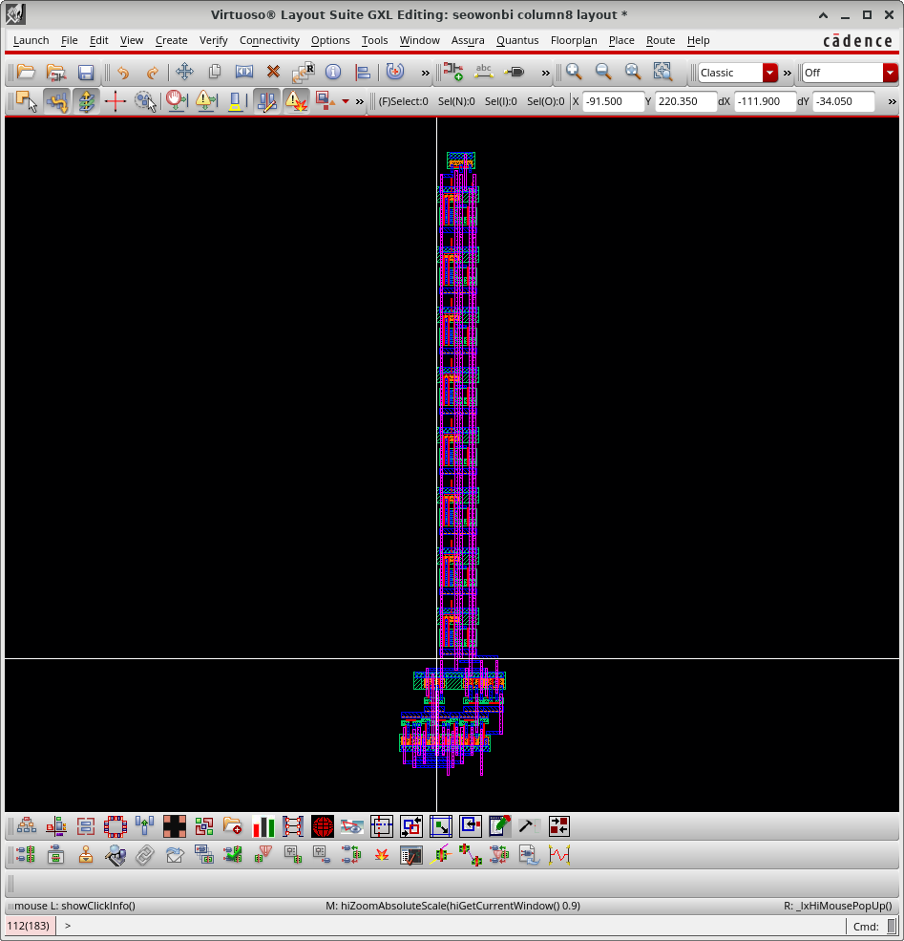

Problem 5 – Address Decoder Schematic
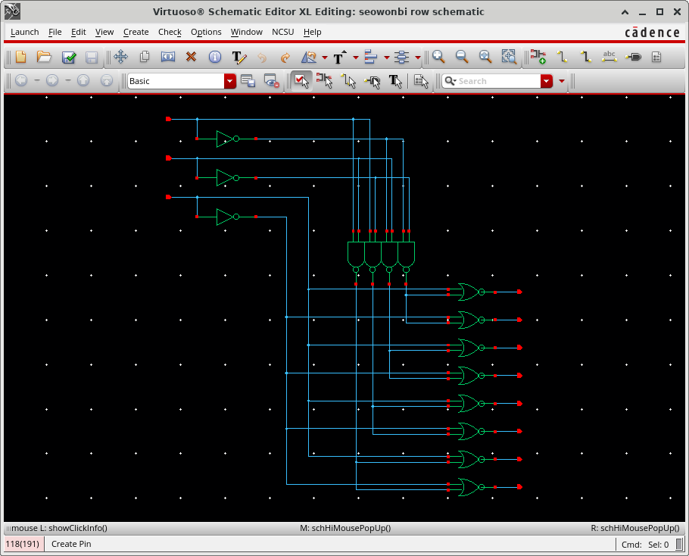

Problem 5 – Address Decoder Symbol
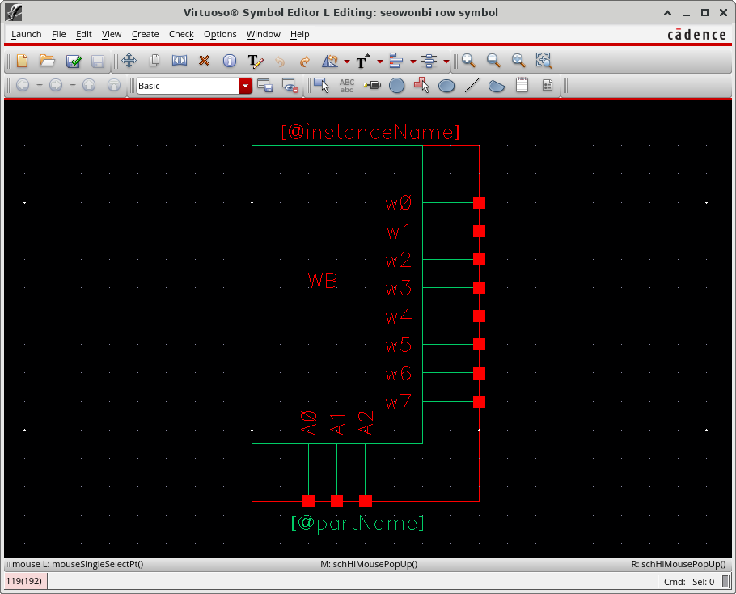

Problem 5 – Address Decoder Layout
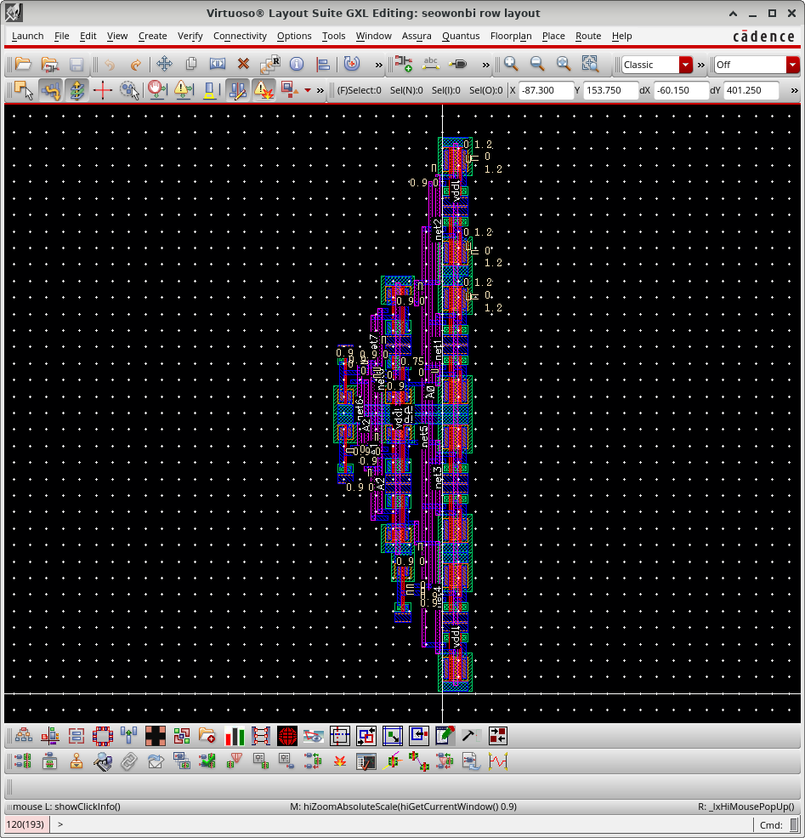

Problem 6 – 8x8 SRAM Schematic
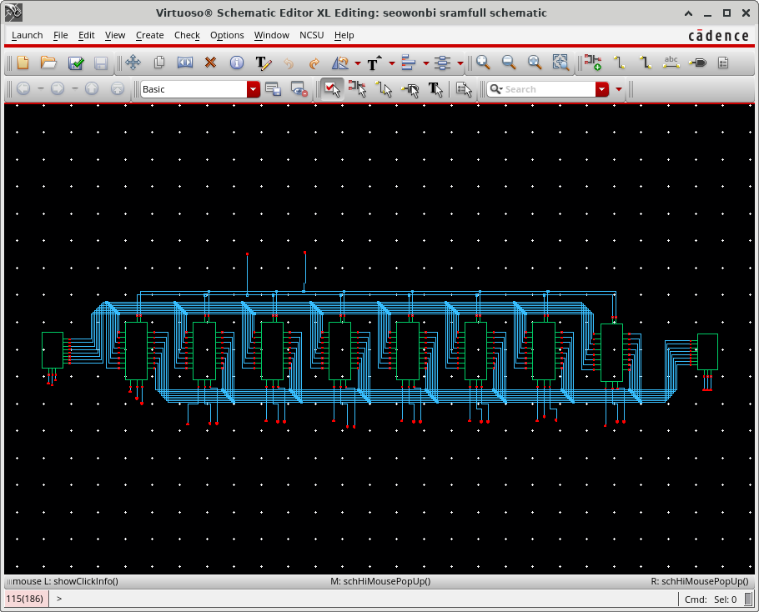

Problem 6 – 8x8 SRAM Symbol
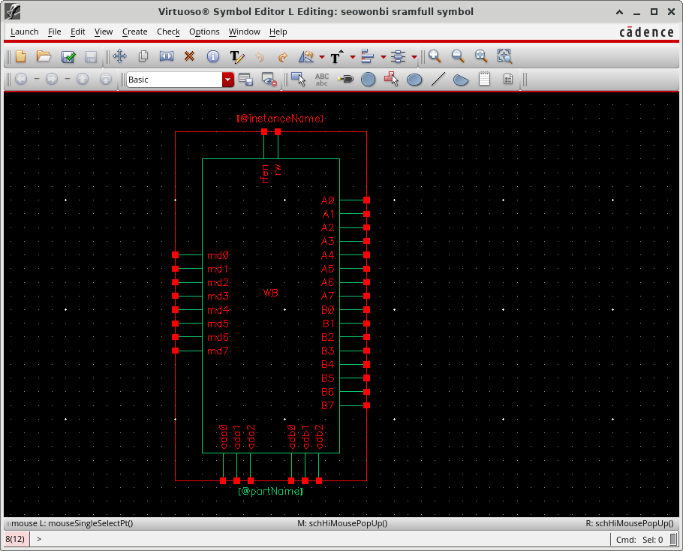

Problem 6 – 8x8 SRAM Layout
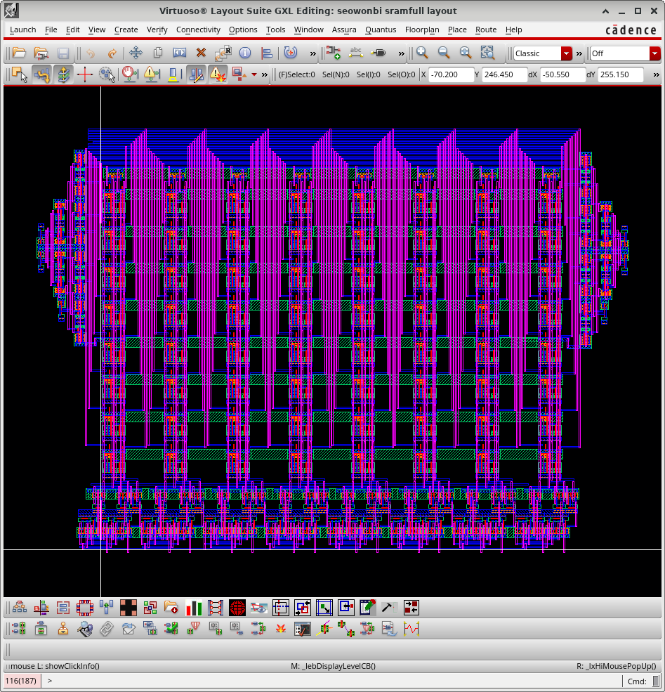

Problem 6 – 8x8 SRAM LVS
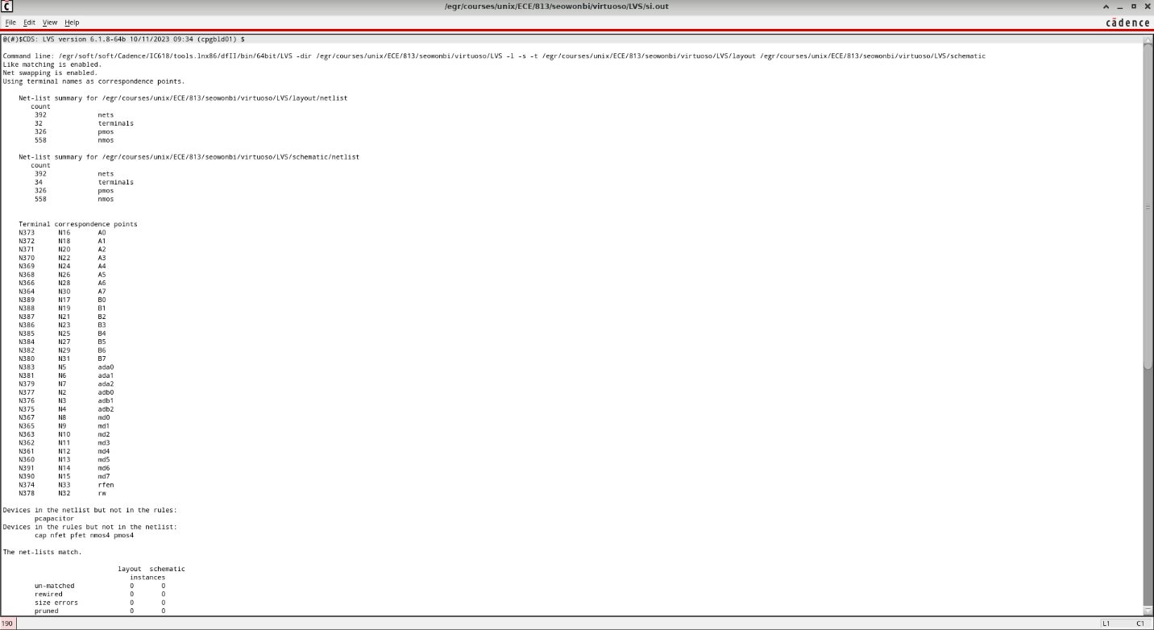

Problem 7 – 8x8 SRAM Simulation
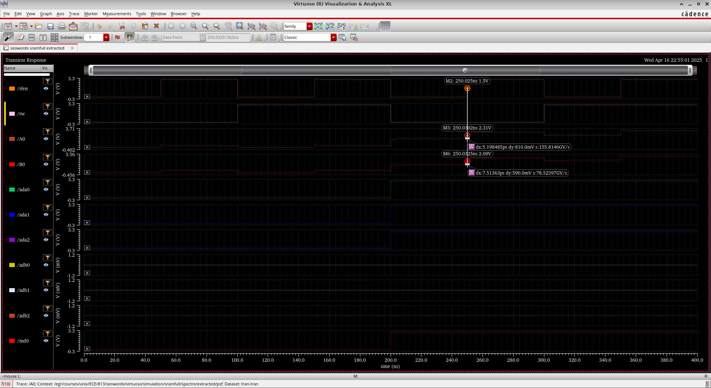

Problem 7 – 8x8 SRAM Stimulus File
simulator lang=spectre
global gnd!
parameters t0=25n tt=0.050n
Vdd (vdd! 0) vsource dc=3
Gnd (gnd! 0) vsource dc=0

v1 (ada0 0) vsource type=pwl wave = \[
+ (0*t0) 0
+ (8*t0) 0
+ (8*t0+tt) 3
+ ]
v2 (ada1 0) vsource type=pwl wave = \[
+ (0*t0) 0
+ (8*t0) 0
+ (8*t0+tt) 3
+ ]
v3 (ada2 0) vsource type=pwl wave = \[
+ (0*t0) 0
+ (8*t0) 0
+ (8*t0+tt) 3
+ ]
v4 (adb0 0) vsource type=pwl wave = \[
+ (0*t0) 0
+ ]
v5 (adb1 0) vsource type=pwl wave = \[
+ (0*t0) 0
+ ]
v6 (adb2 0) vsource type=pwl wave = \[
+ (0*t0) 0
+ ]
v7 (md0 0) vsource type=pwl wave = \[
+ (0*t0) 0
+ (8*t0) 0
+ (8*t0+tt) 3
+ ]
v8 (md1 0) vsource type=pwl wave = \[
+ (0*t0) 0
+ (8*t0) 0
+ (8*t0+tt) 3
+ ]
v9 (md2 0) vsource type=pwl wave = \[
+ (0*t0) 0
+ (8*t0) 0
+ (8*t0+tt) 3
+ ]
v10 (md3 0) vsource type=pwl wave = \[
+ (0*t0) 0
+ (8*t0) 0
+ (8*t0+tt) 3
+ ]
v11 (md4 0) vsource type=pwl wave = \[
+ (0*t0) 0
+ (8*t0) 0
+ (8*t0+tt) 3
+ ]
v12 (md5 0) vsource type=pwl wave = \[
+ (0*t0) 0
+ (8*t0) 0
+ (8*t0+tt) 3
+ ]
v13 (md6 0) vsource type=pwl wave = \[
+ (0*t0) 0
+ (8*t0) 0
+ (8*t0+tt) 3
+ ]
v14 (md7 0) vsource type=pwl wave = \[
+ (0*t0) 0
+ (8*t0) 0
+ (8*t0+tt) 3
+ ]
v15 (rw 0) vsource type=pwl wave = \[
+ (0*t0) 0
+ (4*t0) 0
+ (4*t0+tt) 3
+ (8*t0) 3
+ (8*t0+tt) 0
+ (12*t0) 0
+ (12*t0+tt) 3
+ ]
v16 (rfen 0) vsource type=pwl wave = \[
+ (0*t0) 0
+ (2*t0) 0
+ (2*t0+tt) 3
+ (4*t0) 3
+ (4*t0+tt) 0
+ (6*t0) 0
+ (6*t0+tt) 3
+ (8*t0) 3
+ (8*t0+tt) 0
+ (10*t0) 0
+ (10*t0+tt) 3
+ (12*t0) 3
+ (12*t0+tt) 0
+ (14*t0) 0
+ (14*t0+tt) 3
+ ]

c0 (0 A0) capacitor c=3f
c1 (0 B0) capacitor c=3f
c2 (0 A1) capacitor c=3f
c3 (0 B0) capacitor c=3f
c4 (0 A2) capacitor c=3f
c5 (0 B2) capacitor c=3f
c6 (0 A3) capacitor c=3f
c7 (0 B3) capacitor c=3f
c8 (0 A4) capacitor c=3f
c9 (0 B4) capacitor c=3f
c10 (0 A5) capacitor c=3f
c11 (0 B5) capacitor c=3f
c12 (0 A6) capacitor c=3f
c13 (0 B6) capacitor c=3f
c14 (0 A7) capacitor c=3f
c15 (0 B7) capacitor c=3f

